  LED Balloon Lights

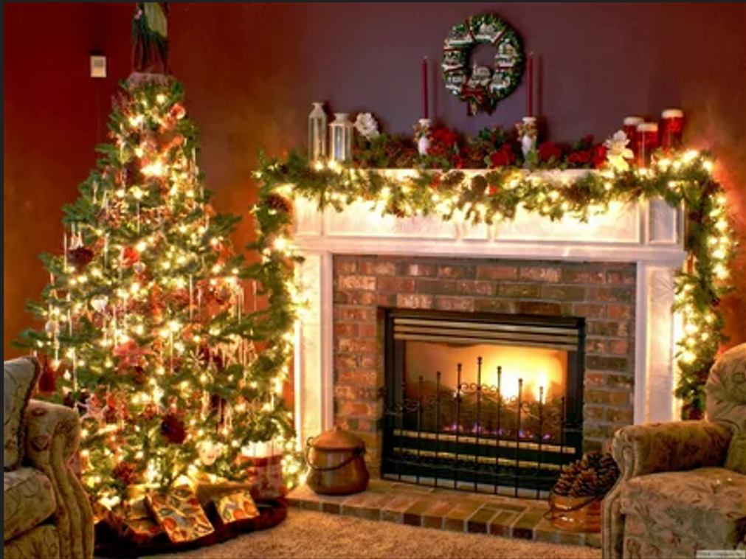

#### ****Description:****

**LED Balloon Lights** are innovative, energy-efficient lighting solutions designed to add a festive and whimsical touch to any event. These lights are perfect for creating a magical ambiance at parties, weddings, and outdoor gatherings. With their balloon-like design and vibrant colors, LED Balloon Lights offer a unique and eye-catching lighting experience.

* **Technology:** LED.
* **Power Source:** Battery-operated (typically CR2032 batteries).
* **Bulb Type:** Integrated LED (non-replaceable).
* **Wattage:** 0.5W per light.
* **Lumens:** 10 lumens per light.
* **Color Options:** Multicolor, warm white, cool white.
* **Dimmable:** No.
* **Lifespan:** 20,000 hours.
* **Energy Efficiency:** Energy-efficient LED technology.
* **Weather Resistance:** Splash-proof for outdoor use.

#### ****Key Features:****

* **Balloon Design:** Mimics the look of real balloons with a glowing effect.
* **Energy-Efficient:** Uses LED technology for long-lasting and energy-saving performance.
* **Vibrant Colors:** Available in multicolor and single-color options for a festive look.
* **Versatile Use:** Suitable for indoor and outdoor settings, including parties, weddings, and home decor.
* **Easy to Use:** Simply inflate the balloon and turn on the light.
* **Portable:** Lightweight and easy to carry, making them perfect for events.

#### ****Pricing:****

* **10-Pack LED Balloon Lights (Multicolor):** $24.99
* **20-Pack LED Balloon Lights (Multicolor):** $44.99
* **10-Pack LED Balloon Lights (Warm White):** $19.99
* **20-Pack LED Balloon Lights (Warm White):** $34.99

#### ****Where to Use:****

* **Parties:** Add a festive touch to indoor and outdoor celebrations.
* **Weddings:** Create a romantic and whimsical ambiance for ceremonies and receptions.
* **Home Decor:** Enhance living rooms, patios, and balconies with vibrant lighting.
* **Commercial Displays:** Highlight storefronts, events, and promotional setups.
* **Outdoor Spaces:** Illuminate gardens, fences, and outdoor decor.

### ****Customer Reviews:****

* ⭐⭐⭐⭐⭐ "These LED Balloon Lights are fantastic! They add such a lively and festive touch to my parties and outdoor events." – Sarah L.
* ⭐⭐⭐⭐ "Great value for the price. The lights are bright, and the multicolor option is perfect for creating a fun atmosphere." – James T.
* ⭐⭐⭐⭐⭐ "I love how energy-efficient these lights are. The balloon design is unique and eye-catching." – Emily R.

### ****How to Order:****

1. Visit our website: [www.brightworldlighting.com](http://www.brightworldlighting.com/)
2. Select your preferred pack size and color option (Multicolor or Warm White).
3. Add to cart and proceed to checkout.
4. Enjoy free shipping on all orders over $50!

### ****Warranty and Support:****

* **Warranty:** 1-year limited warranty covering manufacturing defects.
* **Customer Support:** Contact us at [support@brightworldlighting.com](mailto:support@brightworldlighting.com) or call +1-800-123-4567 for assistance.

### ****Visual Representation:****

Include high-quality images of the LED Balloon Lights in different settings (e.g., parties, weddings) to showcase their versatility and design.